Simulaciones

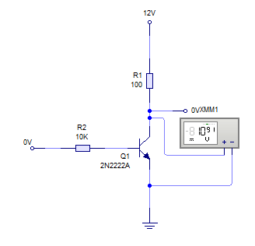

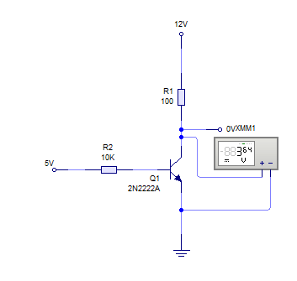

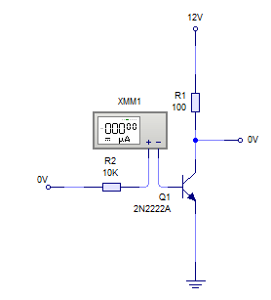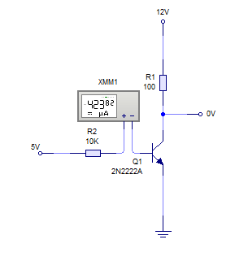

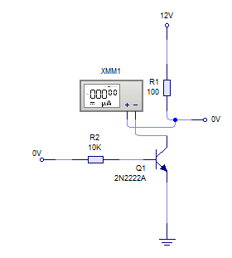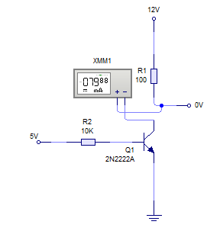

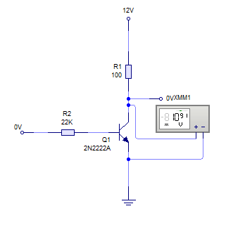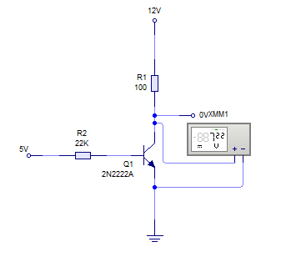

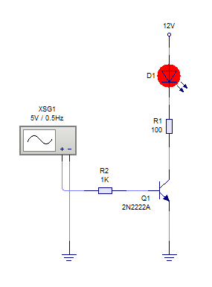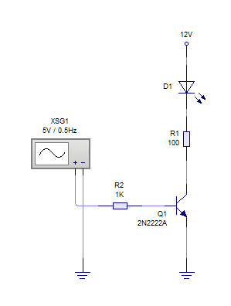Led

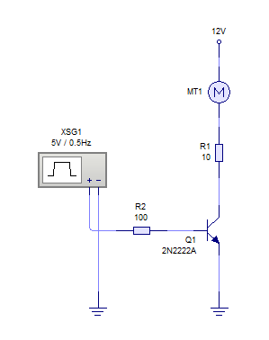Motor

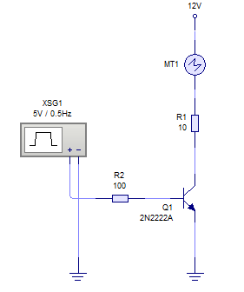

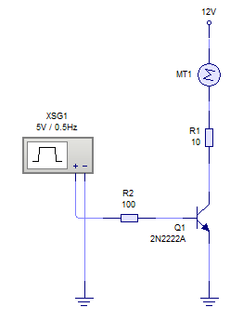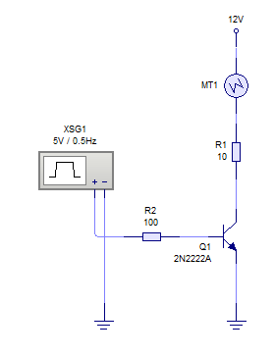

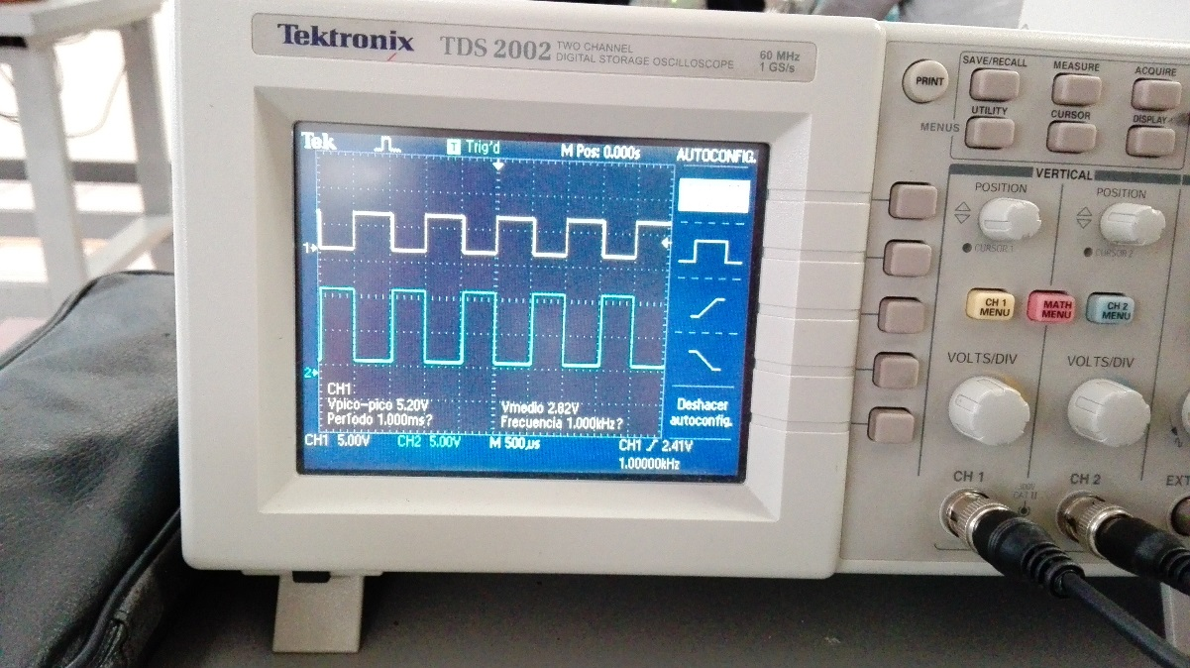

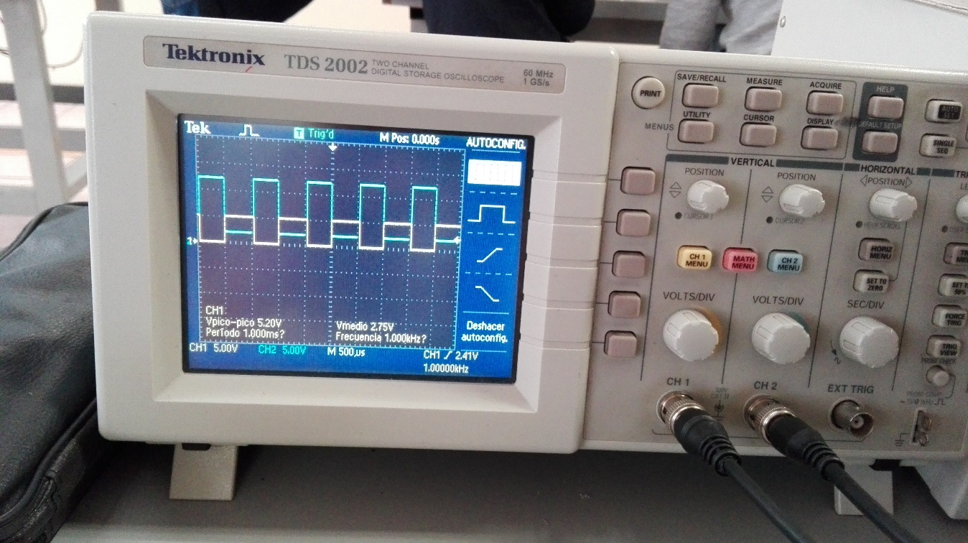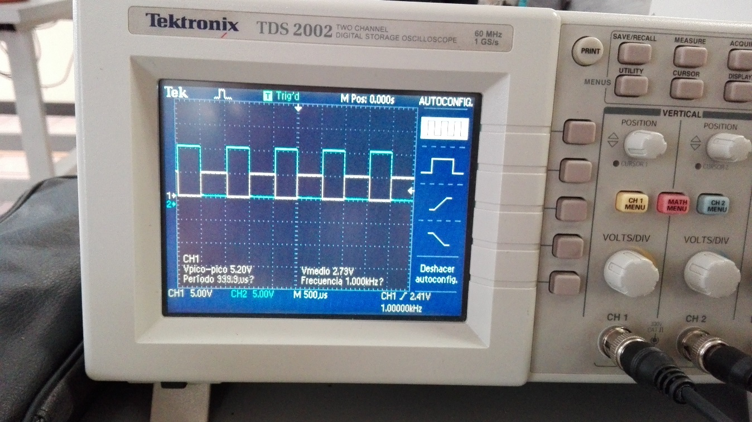

Questionnaire

1. **What is the saturation zone of a two-pole transistor?**

He appears when the potential difference between the collector and the issuer gets down below the value threshold VCE, sat.

1. **What is the zone of court of a two-pole transistor?**

It is possible to say that the union CE behaves as an opened circuit, since the current that crosses it is zero.

1. **Does that differs exist between the transistor 2N2222 and TIP41?**

The transistor 2N2222 it is a transistor of silicon and fall promotes, designed for applications of linear amplification and commutation and the transistor TIP41 it can amplify small currents to small or average tensions and work to moderately high frequencies.

1. **It mentions 3 applications of circuits in commutation**

* BJT in digital applications
* The transistor like switchboard in off and on
* Multivibrator biestable (flip-flop)

Conclusions

The functioning of a transistor is important since it can help us to amplify a sign, to reducing the circuit, with practical this one, it was possible to observe the correct functioning of the transistors and the form in which they must go connected; we can apply this type of circuits to future projects, and since I observe since it works equally implanting any engine or led